5. Write a program to compute the average waiting time and turnaround time based on Preemptive shortest remaining processing time first (SRPT) algorithm for the following set of processes, with the arrival times and the CPU-burst times given in milliseconds

Process Arrival Time Burst Time

P1 0 5

P2 1 3

P3 2 3

P4 4 1

Program:

#include <stdio.h>

struct process {

int arrival_time;

int burst_time;

int remaining_time;

int waiting_time;

int turnaround_time;

int completed;

};

int main() {

int n = 4, t = 0, min_burst_time, min_index;

struct process processes[] = {

{0, 5, 5, 0, 0, 0},

{1, 3, 3, 0, 0, 0},

{2, 3, 3, 0, 0, 0},

{4, 1, 1, 0, 0, 0}

};

while (1) {

min_burst_time = 9999;

min_index = -1;

for (int i = 0; i < n; i++) {

if (processes[i].arrival_time <= t && processes[i].completed == 0) {

if (processes[i].remaining_time < min_burst_time) {

min_burst_time = processes[i].remaining_time;

min_index = i;

}

}

}

if (min_index == -1) {

break;

}

processes[min_index].remaining_time--;

t++;

for (int i = 0; i < n; i++) {

if (processes[i].arrival_time <= t && processes[i].completed == 0) {

if (i != min_index) {

processes[i].waiting_time++;

}

if (processes[i].remaining_time == 0) {

processes[i].completed = 1;

processes[i].turnaround_time = t - processes[i].arrival_time;

}

}

}

}

float avg_waiting_time = 0, avg_turnaround_time = 0;

for (int i = 0; i < n; i++) {

avg_waiting_time += processes[i].waiting_time;

avg_turnaround_time += processes[i].turnaround_time;

}

avg_waiting_time /= n;

avg_turnaround_time /= n;

printf("Average Waiting Time: %.2f ms\n", avg_waiting_time);

printf("Average Turnaround Time: %.2f ms\n", avg_turnaround_time);

return 0;

}

Output:

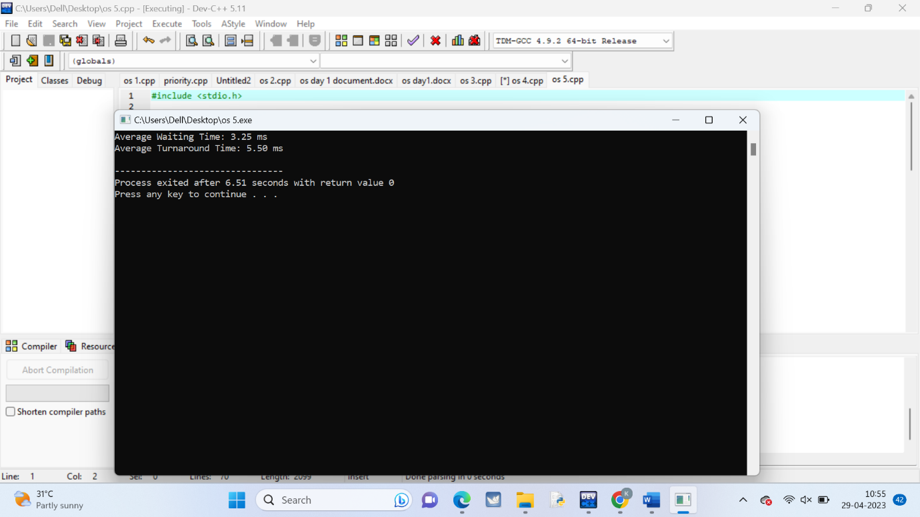

6. Write a C program to implement the deadlock detection algorithm for a system with 3 processes and 3 resource instances and the resource matrices are given below.

Max Matrix Allocation Matrix

3 6 8 3 3 3

4 3 3 2 0 3

3 4 4 1 2 4

The number of available resources is [1,2,0]. Determine if the system is in a deadlock state and identify the deadlocked processes.

Program:

#include <stdio.h>

int main() {

// Define the Max and Allocation matrices

int max[3][3] = {{3, 6, 8}, {4, 3, 3}, {3, 4, 4}};

int allocation[3][3] = {{3, 3, 3}, {2, 0, 3}, {1, 2, 4}};

// Define the Available vector

int available[3] = {1, 2, 0};

// Define the Work and Finish vectors

int work[3], finish[3] = {0, 0, 0};

// Initialize the Work vector to the Available vector

for (int i = 0; i < 3; i++) {

work[i] = available[i];

}

// Initialize the Need matrix to the Max matrix minus the Allocation matrix

int need[3][3];

for (int i = 0; i < 3; i++) {

for (int j = 0; j < 3; j++) {

need[i][j] = max[i][j] - allocation[i][j];

}

}

// Detect deadlock by checking for a safe sequence

int safe = 0;

while (safe == 0) {

safe = 1;

for (int i = 0; i < 3; i++) {

if (finish[i] == 0) {

int j;

for (j = 0; j < 3; j++) {

if (need[i][j] > work[j]) {

break;

}

}

if (j == 3) {

// Process i can complete

safe = 0;

finish[i] = 1;

for (int k = 0; k < 3; k++) {

work[k] += allocation[i][k];

}

}

}

}

}

// Print the results

int deadlock = 1;

printf("Deadlocked processes: ");

for (int i = 0; i < 3; i++) {

if (finish[i] == 0) {

printf("%d ", i + 1);

deadlock = 0;

}

}

if (deadlock == 1) {

printf("None");

}

printf("\n");

return 0;

}

Output:

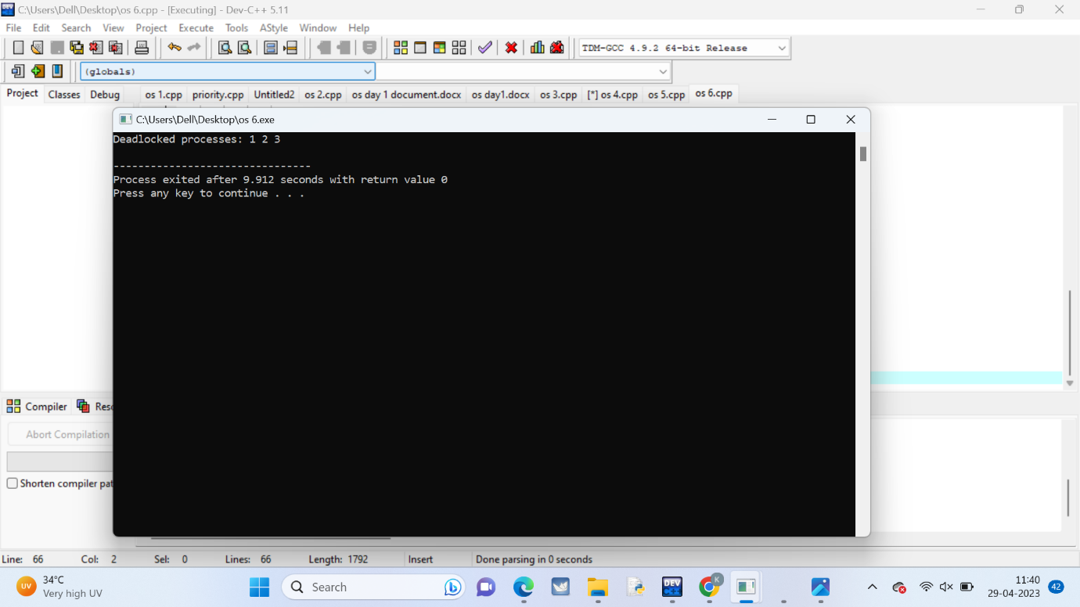

7. Write a C program to illustrate the page replacement method where the current least recently used element is replaced and determine the number of page faults for the following test case:

No. of page frames: 3; Page reference sequence 1,2,3,2,1,5,2,1,6,2,5,6,3,1,3,6,1,2,4 and 3.

Program:

#include <stdio.h>

#define MAX_PAGES 20

int main() {

int pageFrames, pageFaults = 0, time = 0;

int pageReferences[MAX_PAGES], pageTable[MAX_PAGES];

int i, j, oldestPage, oldestTime;

printf("Enter the number of page frames: ");

scanf("%d", &pageFrames);

printf("Enter the page reference sequence (separated by spaces): ");

for (i = 0; i < MAX_PAGES; i++) {

if (scanf("%d", &pageReferences[i]) != 1) {

break;

}

}

int numPages = i;

for (i = 0; i < pageFrames; i++) {

pageTable[i] = -1;

}

for (i = 0; i < numPages; i++) {

int page = pageReferences[i];

int inPageTable = 0;

for (j = 0; j < pageFrames; j++) {

if (pageTable[j] == page) {

inPageTable = 1;

break;

}

}

if (inPageTable) {

printf("Page %d is already in memory\n", page);

} else {

pageFaults++;

printf("Page fault: Page %d\n", page);

oldestPage = pageTable[0];

oldestTime = time;

for (j = 0; j < pageFrames; j++) {

if (pageTable[j] == -1) {

oldestPage = pageTable[j];

break;

} else if (oldestTime > pageTable[j]) {

oldestPage = pageTable[j];

oldestTime = pageTable[j];

}

}

for (j = 0; j < pageFrames; j++) {

if (pageTable[j] == oldestPage) {

pageTable[j] = page;

break;

}

}

}

for (j = 0; j < pageFrames; j++) {

if (pageTable[j] != -1) {

pageTable[j]++;

}

}

time++;

}

printf("Total page faults: %d\n", pageFaults);

return 0;

}

Output:

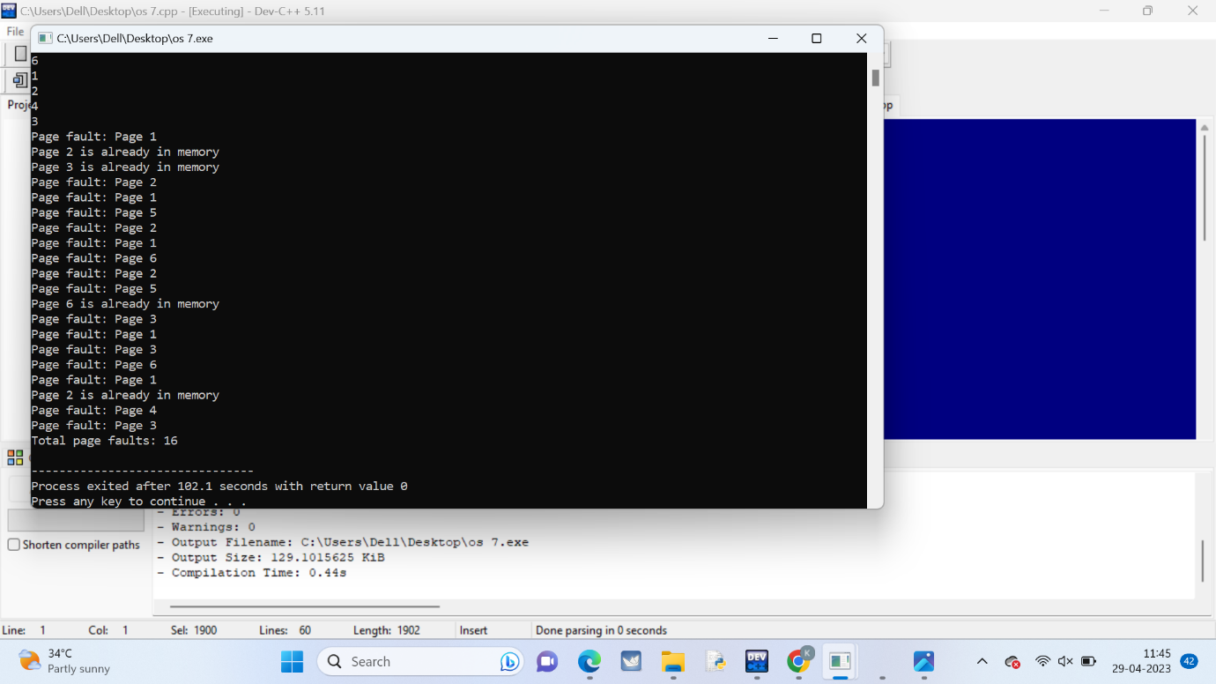

**8.** Write a C program to simulate FCFS disk scheduling algorithm and execute your program and find the average head movement with the following test case:

No of tracks 5; Track position:55 58 60 70 18

**Program:**

**#include <stdio.h>**

**#include <stdlib.h>**

**#define MAX_TRACKS 1000**

**int main() {**

**int tracks[MAX_TRACKS];**

**int n, head_pos, total_distance;**

**printf("Enter number of tracks: ");**

**scanf("%d", &n);**

**printf("Enter track positions: ");**

**for (int i = 0; i < n; i++) {**

**scanf("%d", &tracks[i]);**

**}**

**printf("Enter initial head position: ");**

**scanf("%d", &head_pos);**

**total_distance = 0;**

**for (int i = 0; i < n; i++) {**

**total_distance += abs(tracks[i] - head_pos);**

**head_pos = tracks[i];**

**}**

**printf("Total head movement: %d\n", total_distance);**

**printf("Average head movement: %.2f\n", (float) total_distance / n);**

**return 0;**

**}**

**Output:**

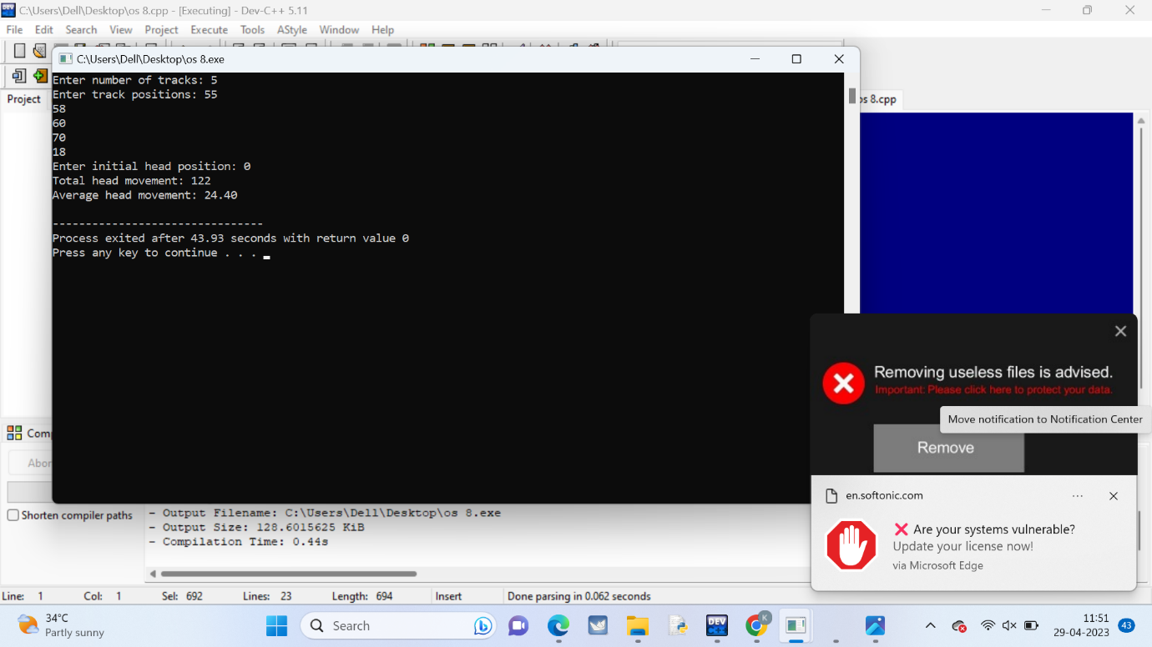

**9.** Consider three processes (process id 0, 1, 2 respectively) with compute time bursts 2, 4 and 8-time units. All processes arrive at time zero. Write a program to compute the average waiting time and average turnaround time based on First Come First Serve scheduling

**Program:**

**#include<stdio.h>**

**int main()**

**{**

**int n = 3;**

**int burst_time[] = {2, 4, 8};**

**int waiting_time[n], turnaround_time[n];**

**int i, j;**

**waiting_time[0] = 0;**

**for(i=1; i<n; i++)**

**{**

**waiting_time[i] = 0;**

**for(j=0; j<i; j++)**

**{**

**waiting_time[i] += burst_time[j];**

**}**

**}**

**for(i=0; i<n; i++)**

**{**

**turnaround_time[i] = waiting_time[i] + burst_time[i];**

**}**

**float avg_waiting_time = 0, avg_turnaround_time = 0;**

**for(i=0; i<n; i++)**

**{**

**avg_waiting_time += waiting_time[i];**

**avg_turnaround_time += turnaround_time[i];**

**}**

**avg_waiting_time /= n;**

**avg_turnaround_time /= n;**

**printf("Process\tBurst Time\tWaiting Time\tTurnaround Time\n");**

**for(i=0; i<n; i++)**

**{**

**printf("%d\t%d\t\t%d\t\t%d\n", i, burst_time[i], waiting_time[i], turnaround_time[i]);**

**}**

**printf("Average Waiting Time: %.2f\n", avg_waiting_time);**

**printf("Average Turnaround Time: %.2f\n", avg_turnaround_time);**

**return 0;**

**}**

**Output:**

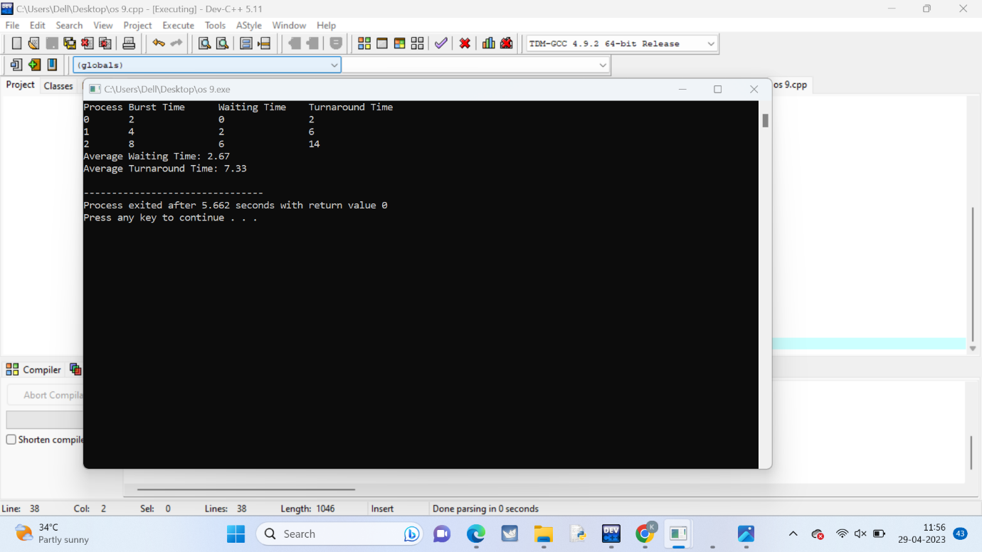

**10.** Consider the following process table with number of processes that contains allocation field (for showing the number of resources of type: A, B and C allocated to each process in the table), max field (for showing the maximum number of resources of type: A, B, and C that can be allocated to each process). Write a program to calculate the entries of need matrix using the formula: (Need)i = (Max)i - (Allocation)i

|  |  |  |  |
| --- | --- | --- | --- |
| Process | Allocation | Max | Availble |
|  | A B C | A B C | A B C |
| P0 | 1 1 2 | 5 4 4 | 3 2 1 |
| P1 | 2 1 2 | 4 3 3 |  |
| P2 | 3 0 1 | 9 1 3 |  |
| P3 | 0 2 0 | 8 6 4 |  |
| P4 | 1 1 2 | 2 2 3 |  |

**Program:**

**#include <stdio.h>**

**#define N_PROCESSES 5**

**#define N_RESOURCES 3**

**int main()**

**{**

**int allocation[N_PROCESSES][N_RESOURCES] = {{1, 1, 2}, {2, 1, 2}, {3, 0, 1}, {0, 2, 0}, {1, 1, 2}};**

**int max[N_PROCESSES][N_RESOURCES] = {{5, 4, 4}, {4, 3, 3}, {9, 1, 3}, {8, 6, 4}, {2, 2, 3}};**

**int available[N_RESOURCES] = {3, 3, 2};**

**int need[N_PROCESSES][N_RESOURCES];**

**int i, j;**

**for(i=0; i<N_PROCESSES; i++)**

**{**

**for(j=0; j<N_RESOURCES; j++)**

**{**

**need[i][j] = max[i][j] - allocation[i][j];**

**}**

**}**

**printf("Need matrix:\n");**

**printf(" A B C\n");**

**for(i=0; i<N_PROCESSES; i++)**

**{**

**printf("P%d ", i);**

**for(j=0; j<N_RESOURCES; j++)**

**{**

**printf("%2d ", need[i][j]);**

**}**

**printf("\n");**

**}**

**return 0;**

**}**

**Output:**

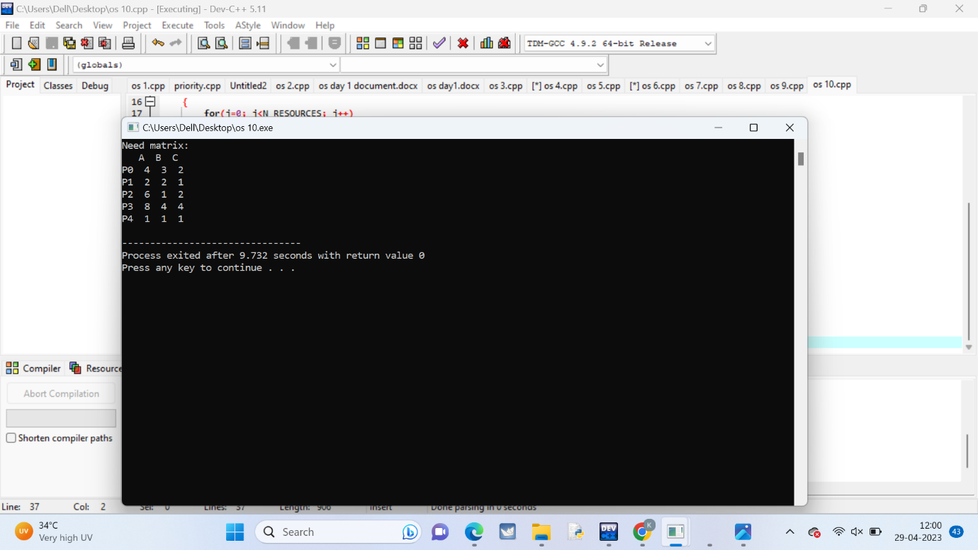

**11.** Write a C program to create 4 child processes. In the first child process, print the odd numbers. In the second child process print the even numbers. In the third child process print the multiple of 3. In the fourth child process print the multiples of 5. Print the process id for each of the processes.

Program:

#include <stdio.h>

#include <unistd.h>

#include <stdlib.h>

int main() {

int i, pid;

for(i=1; i<=4; i++) {

pid = fork();

if(pid == 0) {

switch(i) {

case 1:

printf("Child %d (PID=%d): ", i, getpid());

for(int j=1; j<=10; j++) {

if(j%2 == 1) printf("%d ", j);

}

printf("\n");

break;

case 2:

printf("Child %d (PID=%d): ", i, getpid());

for(int j=1; j<=10; j++) {

if(j%2 == 0) printf("%d ", j);

}

printf("\n");

break;

case 3:

printf("Child %d (PID=%d): ", i, getpid());

for(int j=1; j<=10; j++) {

if(j%3 == 0) printf("%d ", j);

}

printf("\n");

break;

case 4:

printf("Child %d (PID=%d): ", i, getpid());

for(int j=1; j<=10; j++) {

if(j%5 == 0) printf("%d ", j);

}

printf("\n");

break;

}

exit(0);

}

}

return 0;

}

Output: